**How To Compile Kernel 4.1.xx for CentOS**

Contents

**1.** **Download the Kernel Source.** 2

**2.** **Configure the Kernel** 2

**3.** **Patch for RGMII driver** 4

**4.** **Build the Kernel** 5

1. **Download the Kernel Source.**

cd /usr/src

wget –r <https://www.kernel.org/pub/linux/kernel/v4.x/testing/linux-4.1-rc7.tar.xz>

tar xf linux-4.1-rc7.tar.xz

ln -s linux-4.1-rc7 linux

1. **Configure the Kernel**

 Copy the existing configuration to /usr/src/linux:

cd linux

make clean && make mrproper

cp /boot/config-`uname -r` ./.config

make menuconfig

Which brings up the kernel configuration menu. Go to Load an Alternate Configuration File and choose .config (which contains the configuration of your current working kernel) as the configuration file:

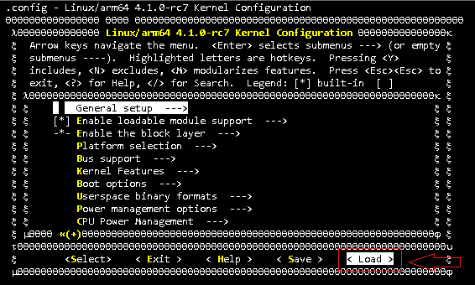

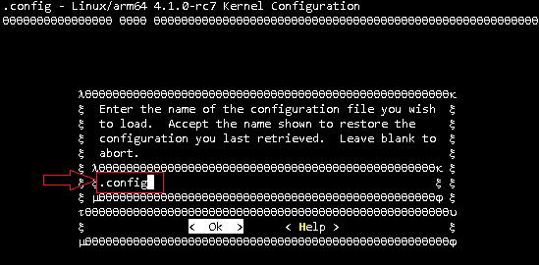

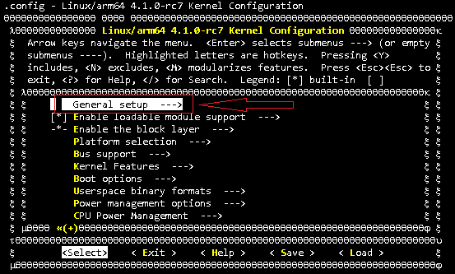

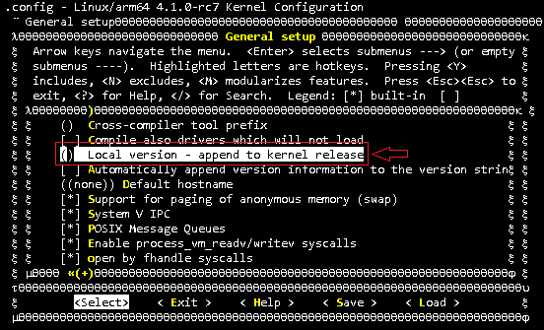

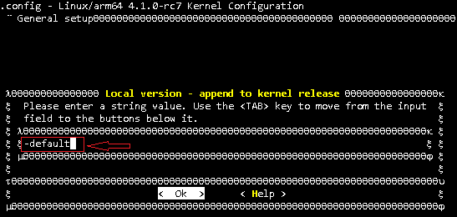

1. **Applying a Kernel Patch for RGMII driver**

wget <https://www.kernel.org/pub/linux/kernel/v4.x/testing/patch-4.1-rc7.xz>

patch –p1 –i 0001-drivers-net-Adjust-RGMII-RX-TX-Delay-to-Ozzy-specifi.patch

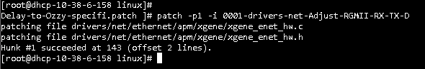

1. **Build the Kernel**

To build the kernel, simply execute this command:

make rpm

Now be patient, the kernel compilation can take some hours, depending on your kernel configuration and your processor speed.

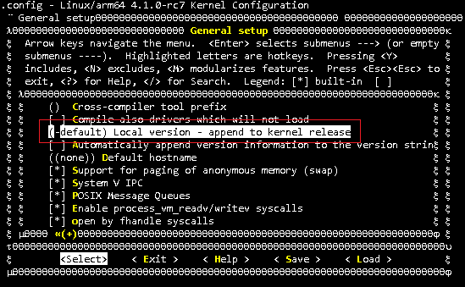

When you are finished and select *Exit*, answer the following question (*Do you wish to save your new kernel configuration?*) with *Yes*:

